LEARNING AGREEMENT
(For information on KIT’s course offer please check https://www.intl.kit.edu/download/OVERSEAS_student_handbook.pdf)

Last name, first name
Date and Place of Birth:
Faculty/Department at KIT

Field of Study at KIT

Home university

Field of Study
(home university)
Semesters studying at KIT | Winter semester (WS) 20…../20….  Summer semester (SS) 20…..

Semester | Course title | Course  number | Type | Credits  (ECTS)

Semester | Course title | Course  number | Type | Credits  (ECTS)
By signing this document, the student, the sending institution and the receiving institution confirm that they approve the proposed Learning Agreement.
The student
Name:
E-mail:
Student’s signature Date:

The sending institution
Name: Function:
Phone number: E-mail:
Date:
Responsible person’s signature and stamp

The receiving institution
Name: Function:
Phone number: E-mail:
Date:
Responsible person’s signature and stamp

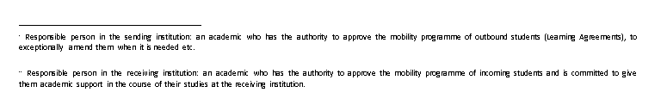

Section to be completed DURING THE MOBILITY

CHANGES TO THE ORIGINAL LEARNING AGREEMENT

Component code (if any) at the receiving institution | Component title (as indicated in the course catalogue) at the receiving institution | Deleted component  [tick if applicable] | Added component  [tick if applicable] | Reason for change | Credits/ ECTS
 |  | □ | □
 |  | □ | □
 |  | □ | □
 |  | □ | □
 |  | □ | □
 |  | □ | □
 |  |  |  |  | Total: …………

Reasons for exceptional changes to study programme abroad:
Reasons for deleting a component | Reason for adding a component
A1) Previously selected educational component is not available at receiving institution | B1) Substituting a deleted component
A2) Component is in a different language than previously specified in the course catalogue | B2) Extending the mobility period
A3) Timetable conflict | B3) Other (please specify)
A4) Other (please specify)

The student, the sending and the receiving institution confirm that they approve the proposed amendments to the mobility programme.
Approval by email or signature of the student and of the sending and receiving institution’s responsible persons.

The student
Student’s signature Date:

The sending institution
Responsible person’s signature Date:

The receiving institution
Responsible person’s signature Date:

WS = winter term from October to March; SS= summer term from April to September
As indicated in the module handbook or course manual
As indicated in the module handbook or course manual
As indicated in the module handbook or course manual
As indicated in the module handbook or course manual, e.g. lecture (“Vorlesung”), exercise (“Übung”), laboratory (“Laborpraktikum”), seminar (“Seminar”) etc.

